# Social Media Share Kit

Child Care Aware® of America

2016 State Fact Sheets

Child Care Aware® of America is pleased to announce the release of our annual State Fact Sheets, [*Checking In: A Snapshot of the Child Care Landscape*](http://usa.childcareaware.org/advocacy-public-policy/resources/research/statefactsheets/) *– 2017 Repor*[*t*](http://usa.childcareaware.org/advocacy-public-policy/resources/research/statefactsheets/)*.* The reauthorization of the Child Care and Development Block Grant (CCDBG) in 2014 represented an enormous step forward in establishing access to quality, affordable child care for all children and families. In the last 6 months, we are now facing proposed drastic cuts to early care programs, education, and social services, which means it is more important than ever to have data that helps make the case for accessible, quality, affordable child care.

Child Care Aware® of America’s 2017 State Fact Sheets provide important data to better understand America’s working families and the circumstances they face. As such, it is a critical tool for child care advocates, policymakers, and program administrators to guide decision-making about child care programs and costs. Data was gathered from federal and national sources and from our state child care resource and referral agency (CCR&R) networks and other CCR&Rs surveyed in 2017. **Please join us in spreading the word about child care facts in your state by following the directions below.**

Copy and paste these posts into your social media channels for sharing. For Facebook, Twitter, email, and LinkedIn we’ve provided simple “click-to-post” options so you do not have to copy and paste the posts. If you are using Instagram, you can copy and paste the content.

To manually post graphics, right click on the graphic and “Save as Picture” to a location on your computer/phone. Then upload the file to your social media post!

**\*Text in purple is meant as an instruction or note – do not copy it into your post\***

Included in this share kit:

* Press Release
* Facebook posts
* Twitter posts
* Instagram posts
* E-mail
* LinkedIn
* Graphics (included throughout posts)

## Press Release

**National Organization Provides Snapshots of State Child Care Landscape**

**Child Care Aware® of America Releases 2017 State Fact Sheets**

**Arlington, VA, July 13, 2017 –** Child Care Aware® of America, the nation’s leading voice for child care, today announced the release of its annual State Fact Sheets, [*Checking In: A Snapshot of the Child Care Landscape – 2017 Report*](http://usa.childcareaware.org/advocacy-public-policy/resources/research/statefactsheets/), which profile child care indicators across all 50 states plus the District of Columbia. This annual report compiles data from local and state child care resource and referral agencies (CCR&Rs), other state agencies, and other federal and national data sets to report on the use, supply, and cost of child care, the child care workforce, and the services provided by CCR&Rs.

The reauthorization of the Child Care and Development Block Grant (CCDBG) in 2014 represented an enormous step forward in establishing access to quality, affordable child care for all children and families. In the last 6 months, the nation has faced the possibility of drastic cuts to early care programs, education, and social services, highlighting the importance of having data that helps make the case for accessible, quality, affordable child care. Child Care Aware® of America’s 2017 State Fact Sheets provide important data to better understand America’s working families and the circumstances they face. As such, it is a critical tool for child care advocates, policymakers, and program administrators to guide decision-making about child care programs and costs.

“Our goal is for the State Fact Sheets to continue to serve as an influential resource and tool for policymakers as important decisions are made concerning child care,” says Lynette M. Fraga, Ph. D., Executive Director of Child Care Aware® of America. “Research shows that quality early care and learning settings play a vital role in the development of children and have a lasting impact. In support of thriving children, families, and communities, it is critical that we advocate for what is needed for quality child care.”

Over the past several years, Child Care Aware® of America has surveyed and conducted focus groups with parents of young children, grandparents, national child advocacy organizations, and state and local CCR&Rs. Those conversations underscored that child care is an essential building block of any community and that investments in child care are investments in our children, our economy, and our future. From our work we have repeatedly confirmed that:

* child care is expensive for all families,
* child care is both a workforce support and an important early learning setting,
* quality of care varies widely,
* child care providers need to receive adequate training,
* child care providers should be paid a livable wage, and
* child care needs to be accessible to diverse populations reflecting the children, families, and communities they serve.

Quality, affordable early childhood programs across the nation are both difficult to find and afford. Through CCDBG, state programs are now tasked with increasing the quality of their programs; however, there is still much work to be done.

The 2017 State Fact Sheets provide data critical to child care and early education advocates, policymakers, and program administrators. The State Fact Sheets can help the child care stakeholder community with the necessary data to better understand the challenges that America’s working families face as they strive to provide their children with care that is safe, healthy, and promotes quality learning and development.

To download a copy of the 2017 State Fact Sheets, visit [**http://usa.childcareaware.org/statefactsheets**](http://usa.childcareaware.org/statefactsheets)**.**

## Facebook

**Click on the Facebook icon for “click-to-post” option OR right click on the image and select “Save Image As” to save to your computer/phone. Then copy and paste the text into a Facebook post and upload the image along with it.**

|  |  |
| --- | --- |
| [Image result for facebook icon](https://www.facebook.com/dialog/feed?app_id=184683071273&link=http://usa.childcareaware.org/advocacy-public-policy/resources/research/statefactsheets/&picture=https://farm5.staticflickr.com/4260/35697927806_713f430846_b.jpg&name=Child%20Care%20Aware%C2%AE%20of%20America%202017%20State%20Fact%20Sheets&caption=%20&description=The%202017%20@USAChildCare%20State%20Fact%20Sheets%20are%20out!%20Get%20important%20stats%20on%20child%20care%20in%20your%20state%20at%20http://usa.childcareaware.org/statefactsheets%20&redirect_uri=http://www.facebook.com/) | FB Post Gen.png  The 2017 @USAChildCare State Fact Sheets are out! Get important stats on child care in your state at <http://usa.childcareaware.org/statefactsheets> |
|  |  |
| [Image result for facebook icon](https://www.facebook.com/dialog/feed?app_id=184683071273&link=http://usa.childcareaware.org/advocacy-public-policy/resources/research/statefactsheets/&picture=https://farm5.staticflickr.com/4206/35051160853_f93be2e745_b.jpg&name=Child%20Care%20Aware%C2%AE%20of%20America%202017%20State%20Fact%20Sheets&caption=%20&description=Use%20statistics%20from%20your%20state%20to%20promote%20informed,%20necessary%20policy%20changes!%20@USAChildCare%20http://usa.childcareaware.org/statefactsheets&redirect_uri=http://www.facebook.com/) | Use statistics from your state to promote informed, necessary policy changes! @USAChildCare <http://usa.childcareaware.org/statefactsheets> |
|  |  |
| [Image result for facebook icon](https://www.facebook.com/dialog/feed?app_id=184683071273&link=http://usa.childcareaware.org/advocacy-public-policy/resources/research/statefactsheets/&picture=https://farm5.staticflickr.com/4280/35020556084_556620ffe9_b.jpg&name=Child%20Care%20Aware%C2%AE%20of%20America%202017%20State%20Fact%20Sheets&caption=%20&description=Advocates%20need%20stats?%20@USAChildCare%20has%20them.%20http://usa.childcareaware.org/statefactsheets&redirect_uri=http://www.facebook.com/) | Advocates need stats? @USAChildCare has them. <http://usa.childcareaware.org/statefactsheets> |
|  |  |

## Twitter

**For easy tweeting, just click the image of the Twitter icon to the left of the post you would like to share. The photo is included, so you don’t have to save the image below.**

**If you choose to post manually, right click on the image below and select “Save Image As” to save to your computer/phone. Then copy and paste the text into a tweet and upload the image along with it.**

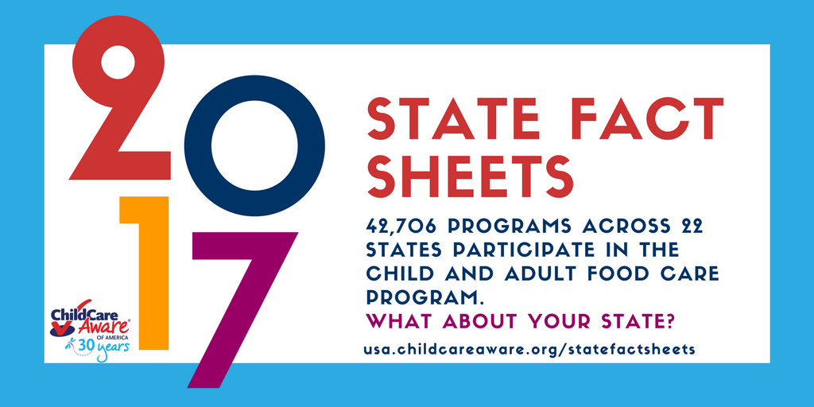

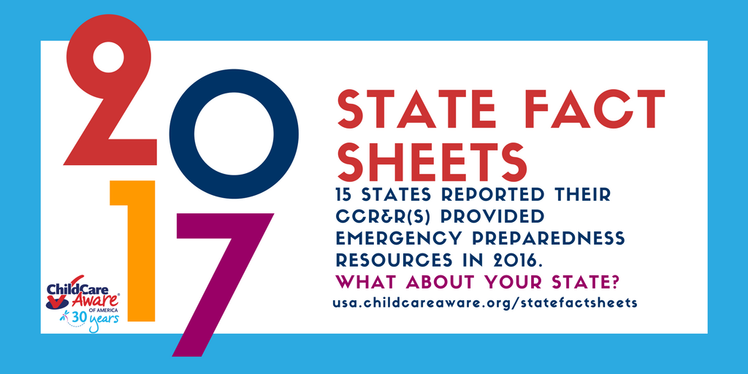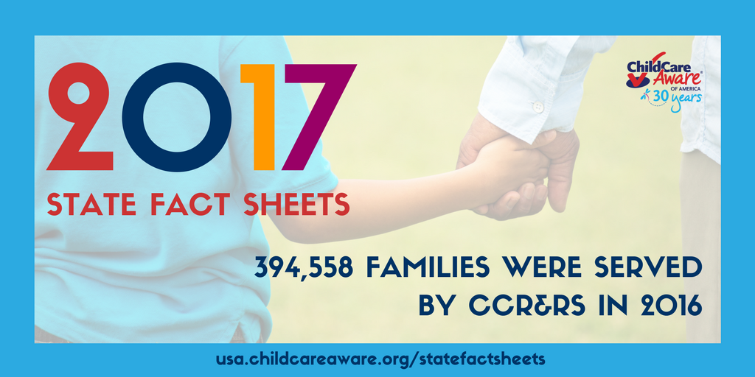

|  |  |
| --- | --- |
| [Image result for twitter logo](https://twitter.com/intent/tweet?text=%20What’s%20the%20#ChildCare landscape look like in your state? @USAchildcare has the facts: http://bit.ly/2to0KFT pic.twitter.com/Iv9RwHDJt7) | What's the #childcare landscape look like in your state? @USAChildCare has the facts: <http://bit.ly/2to0KFT> |
|  |  |
| [Image result for twitter logo](https://twitter.com/intent/tweet?text=%202017%20State%20Fact%20Sheets%20explain%20the%20complex%20#childcare landscape. @USAChildCare: http://bit.ly/2to0KFT pic.twitter.com/Iv9RwHDJt7) | 2017 State Fact Sheets explain the complex #childcare landscape. @USAChildCare: <http://bit.ly/2to0KFT> |
|  |  |
| [Image result for twitter logo](https://twitter.com/intent/tweet?text=Assess%20the%20use,%20supply,%20%26%20cost%20of%20#childcare, the workforce, %26 services provided by CCR%26Rs: http://bit.ly/2to0KFT pic.twitter.com/Iv9RwHDJt7) | Assess the use, supply, & cost of #childcare, the workforce, & services provided by CCR&Rs: <http://bit.ly/2to0KFT> |
|  |  |
| [Image result for twitter logo](https://twitter.com/intent/tweet?text=Approximately%209.7M%20working%20mothers%20have%20children%20under%20age%206.%20How%20many%20are%20in%20your%20state?:%20http://bit.ly/2to0KFT%20pic.twitter.com/Iv9RwHDJt7) | About 9.7M working mothers have children under age 6. How many are in your state? <http://bit.ly/2to0KFT> |
|  |  |
| [Image result for twitter logo](https://twitter.com/intent/tweet?text=There%20are%2015%20mil%20children%20under%206%20with%20all%20parents%20in%20the%20workforce%20in%20need%20of%20#childcare. http://bit.ly/2to0KFT pic.twitter.com/Iv9RwHDJt7) | There are 15 mil children under 6 with all parents in the workforce in need of #childcare. <http://bit.ly/2to0KFT> |
|  |  |
| [Image result for twitter logo](https://twitter.com/intent/tweet?text=CCR%26Rs%20in%2035%20states%20track%20requests%204%20non-traditional%20hours%20to%20help%20recruit%20providers%20%26%20more%20http://bit.ly/2to0KFT%20pic.twitter.com/Iv9RwHDJt7) | CCR&Rs in 35 states track requests 4 non-traditional hours to help recruit providers & more <http://bit.ly/2to0KFT> |
|  |  |
| [Image result for twitter logo](https://twitter.com/intent/tweet?text=15%20states%20reported%20their%20CCR%26R(s)%20provided%20emergency%20preparedness%20resources%20in%202016%20http://bit.ly/2to0KFT%20pic.twitter.com/0UATzOONyK) | 15 states reported their CCR&R(s) provided emergency preparedness resources in 2016 <http://bit.ly/2to0KFT> |
|  |  |
| [Image result for twitter logo](https://twitter.com/intent/tweet?text=42,706%20programs%20across%2022%20states%20participate%20in%20the%20Child%20and%20Adult%20Food%20Care%20Program%20http://bit.ly/2to0KFT%20pic.twitter.com/Iv9RwHDJt7) | 42,706 programs across 22 states participate in the Child and Adult Food Care Program <http://bit.ly/2to0KFT> |
|  |  |
| [Image result for twitter logo](https://twitter.com/intent/tweet?text=17%20states%20report%20they%20have%20a%20network%20for%20Mental%20Health%20Consultants%20for%20child%20care%20providers%20http://bit.ly/2to0KFT%20pic.twitter.com/Iv9RwHDJt7) | 17 states report they have a network for Mental Health Consultants for child care providers <http://bit.ly/2to0KFT> |
|  |  |
| [Image result for twitter logo](https://twitter.com/intent/tweet?text=Over%20833,948%20referral%20requests%20were%20fielded%20by%20CCR%26Rs%20across%20the%20country%20http://bit.ly/2to0KFT%20pic.twitter.com/Iv9RwHDJt7) | Over 833,948 referral requests were fielded by CCR&Rs across the country <http://bit.ly/2to0KFT> |
|  |  |
| [Image result for twitter logo](https://twitter.com/intent/tweet?text=394,558%20families%20were%20served%20by%20CCR%26Rs%20in%202016.%20http://bit.ly/2to0KFT%20pic.twitter.com/DnpfLxkOXv) | 394,558 families were served by CCR&Rs in 2016. <http://bit.ly/2to0KFT> |
|  |  |
| [Image result for twitter logo](https://twitter.com/intent/tweet?text=Language%20offerings%20by%20CCR%26Rs%20include%20Spanish,%20Chinese,%20Tagalog,%20Arabic,%20Swahili,%20and%20more.%20http://bit.ly/2to0KFT%20pic.twitter.com/Iv9RwHDJt7) | Language offerings by CCR&Rs include Spanish, Chinese, Tagalog, Arabic, Swahili, and more. <http://bit.ly/2to0KFT> |
|  |  |

## Instagram

**To share on Instagram pick a post you would like to share. Then, right click on an image and select “Save Image As” to save to your phone. Finally, upload the photo and copy and paste your text.**

What does the #ChildCare landscape look like in your state? @USAChildCare has the facts. #EarlyEd #ECE #EarlyLearning

@USAChildCare released the 2017 State Fact Sheets to help explain the complex #ChildCare landscape in the United States. Advocated like YOU can use them to talk to your members of Congress! #TakeAction #Congress

States can assess the use, supply, and cost of #ChildCare, the workforce, and the services provided by CCR&Rs in the 2017 State Fact Sheets from @USAChildCare. #CCRR #EarlyEd #ECE #EarlyLearning

One year of center-based infant care costs more than a year of tuition at a 4-year public university in 30 states, plus D.C. How does your state measure up? #ChildCare #CCRR #EarlyEd #ECE #EarlyLearning

Use the @USAChildCare fact sheets to guide decision around #ChildCare programs and expenditures at the state level. #TakeAction #CCRR #EarlyED #ECE #EarlyLearning

**\*Images can be found below\***

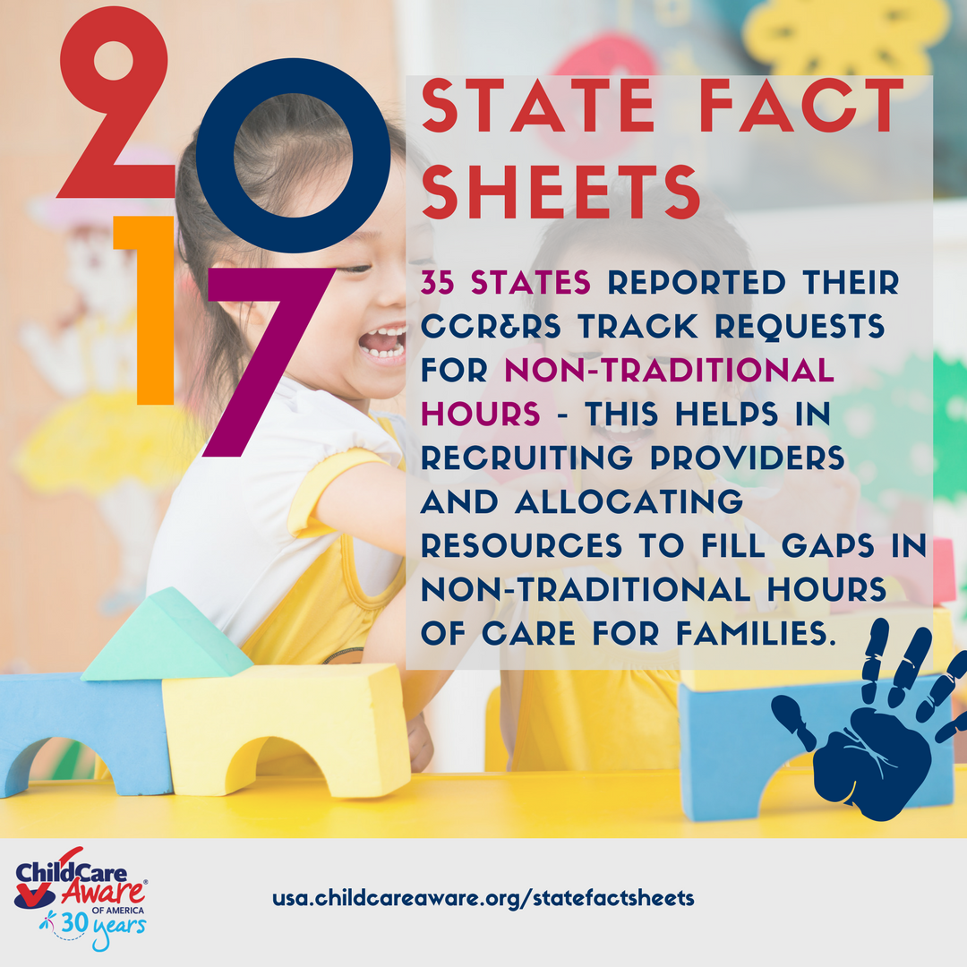

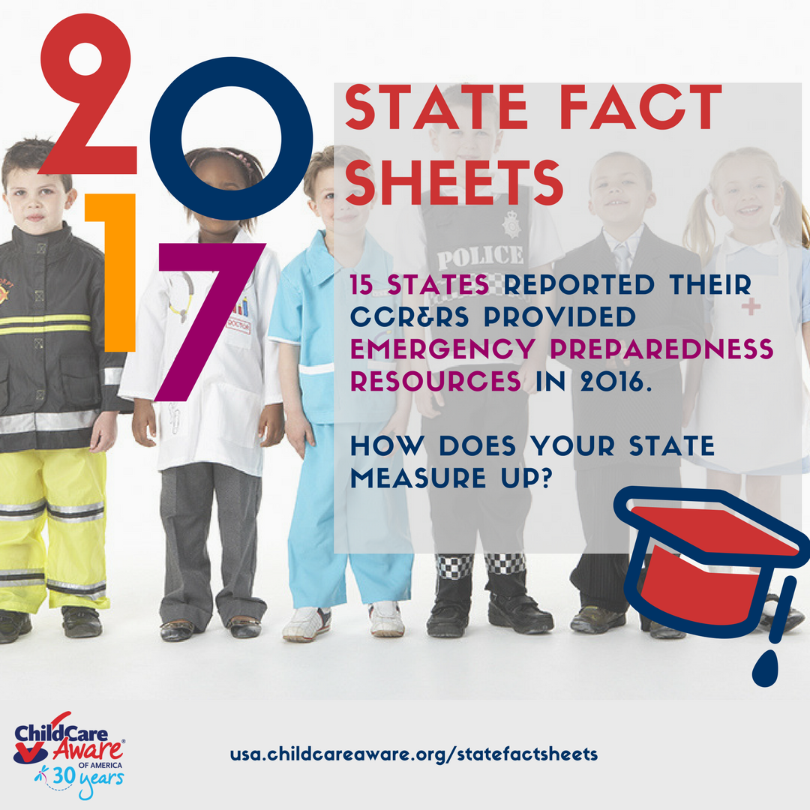

## Email

**You can also share the state fact sheets via e-mail. Click the icon on the left below and then add the recipients you wish to share with OR copy and paste the text and create your own e-mail.**

|  |  |
| --- | --- |
| [Image result for email icon](mailto:?subject=Child%20Care%20Aware%20State%20Fact%20Sheets%20Now%20Available&body=Child%20Care%20Aware%20of%20America%20%C2%AE%20just%20released%20their%202017%20State%20Fact%20Sheets!%20Check%20it%20out%20at:%20http://bit.ly/2to0KFT) | Child Care Aware® of America just released their 2017 State Fact Sheets! Check it out at: <http://bit.ly/2to0KFT> |
|  |  |

## LinkedIn

**To share on LinkedIn, click the icon to the left OR open your own post and copy and paste the text below and post!**

|  |  |
| --- | --- |
| [Image result for linkedin icon](https://www.linkedin.com/shareArticle?mini=true&url=usa.childcareaware.org/statefactsheets&title=Child%20Care%20Aware%20%C2%AE%20of%20America%20State%20Fact%20Sheets&summary=CCAOA%20has%20released%20their%202017%20state%20fact%20sheets.%20Click%20the%20link%20now%20to%20view%20data%20specific%20to%20your%20state.&source=) | **Title:**  Child Care Aware® of America State Fact Sheets  **Summary:**  CCAOA has released their 2017 state fact sheets. Click the link now to view data specific to your state. |
|  | <http://usa.childcareaware.org/statefactsheets> |